**Day 2 Challenge 1**

By Bingsu Strawberry from IIUM

**Step 1:**

We are given a powershell script only. First step we do is try to understand what the script does.

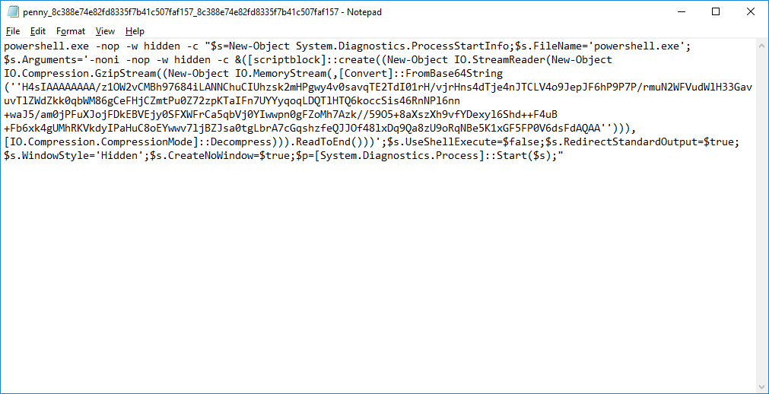

**Step 2 :**

We decompress the compressed part of the script to make sure it is not anything malicious.

We used a website online to decompress it. [Link here](http://www.txtwizard.net/compression)

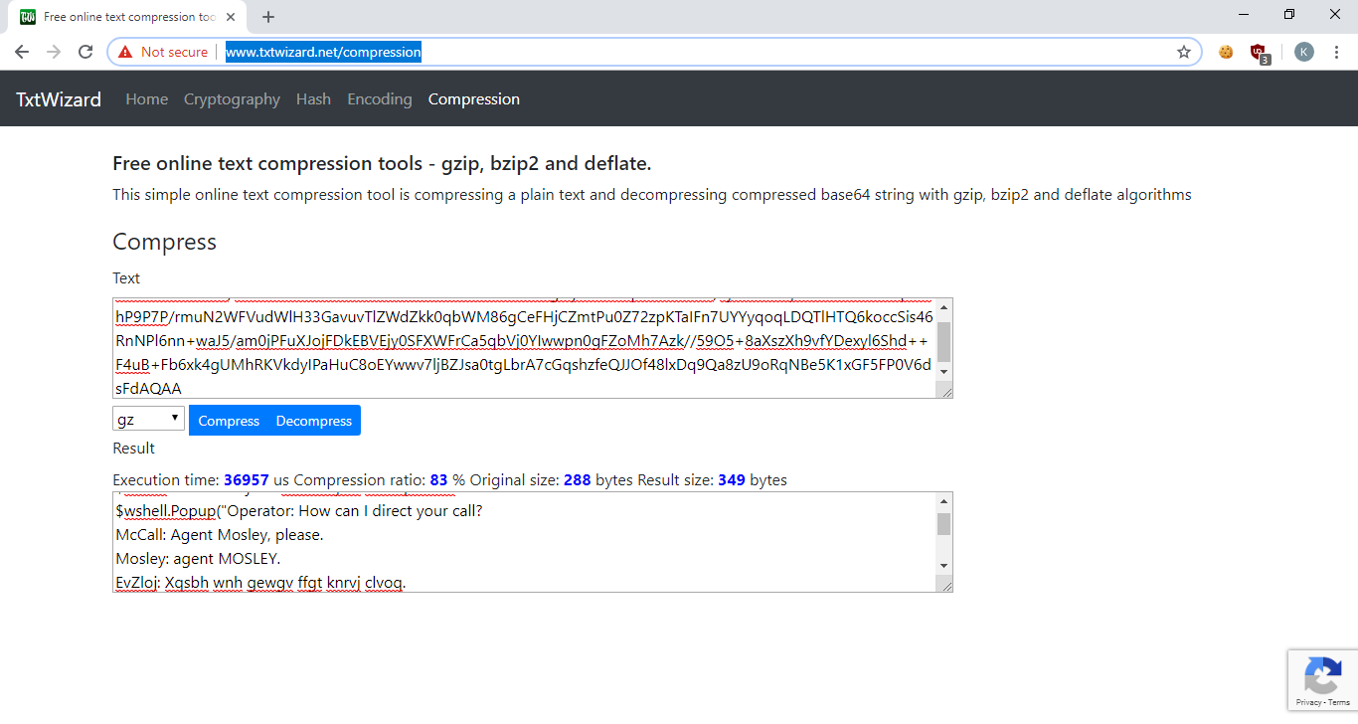

The code doesn’t seem to pose any threats. We think it’s just used to display a message. Time to put it to test!

**Step 3:**

Remove the unnecessary part from the code and put it into powershell and run it.

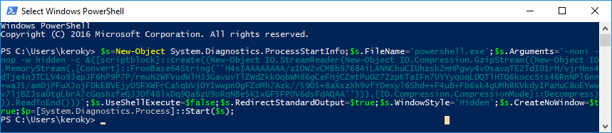

This is the result   
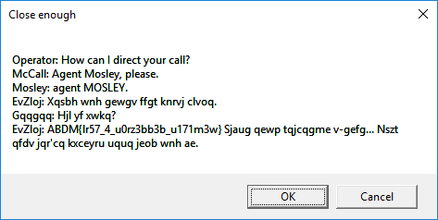

It seems to be a dialog of some sort.

The bottom part seems to be encrypted. We are not sure what type of encryption is used here.

**Step 4:**

A quick google search of the dialog showed that it is from a movie called The Equalizer from the year 2014.

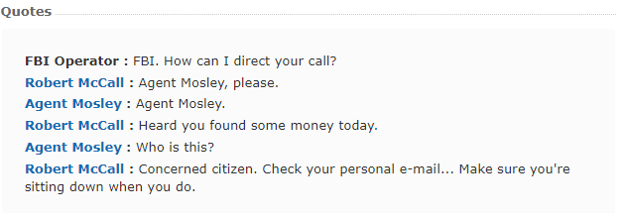

Now we can see a relation between the dialog we have and the actual dialog. The last part seemed to contain our flag.

**Step 5:**

The relation of the flag to the actual dialog :

ABDM{lr57_4_u0rz3bb3b_u171m3w} = concerned citizen

We can assume the last part of the flag to be concerned citizen.

u0rz3bb3b_u171m3w = concerned citizen

We can try to verify this.

**Step 6:**

We believe the flag is written is leet speak or the act of changing letters with numbers .

The text now looks like this

uOrzEbbEb and uITImEw

Try to do a pattern search for the words we have

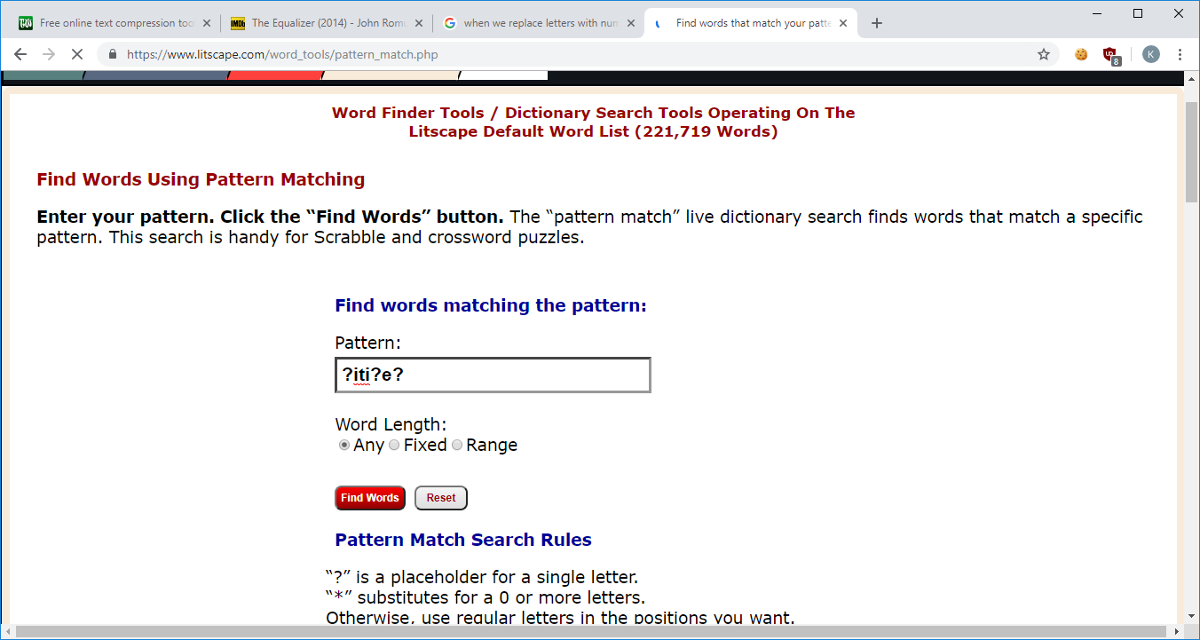

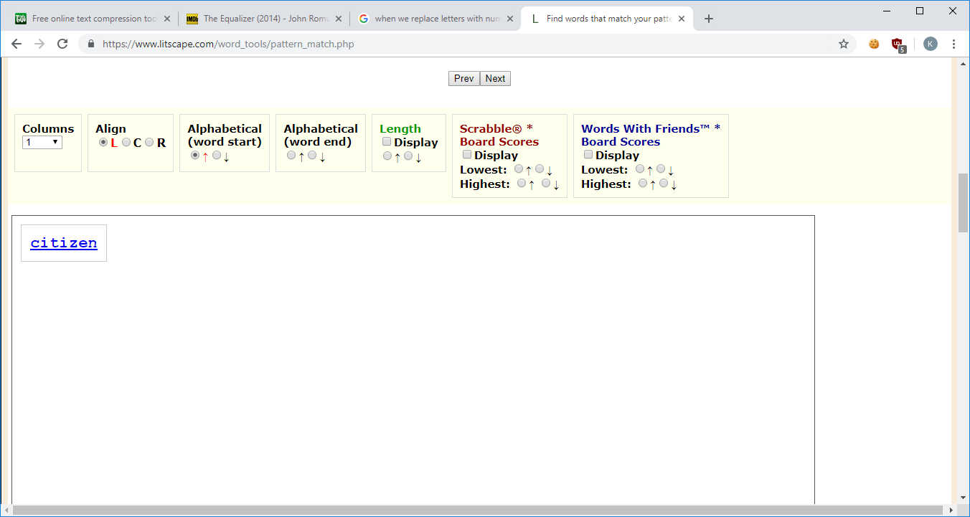

The result is uITImEw = citizen

For the case of uOrzEbbEb , we found 138 words

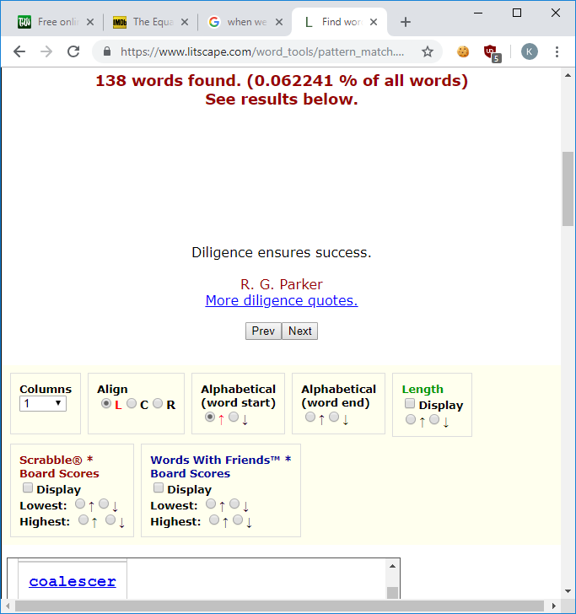

But if we refer back to the original dialog, we can safely assume that uOrzEbbEb = concerned,

Now for the rest of the text, 4 is A .

Doing a pattern finder for lrST yields us 37 words but the most probable word we assume is just. Leaving us with lrST = just.

**Step 7:**

Now our flag looks like ABDM{just_a_concerned_citizen}

Try to convert it back to the format it usually is and we get

KPMG{ju57_4_c0nc3rn3d_c171z3n} as our flag